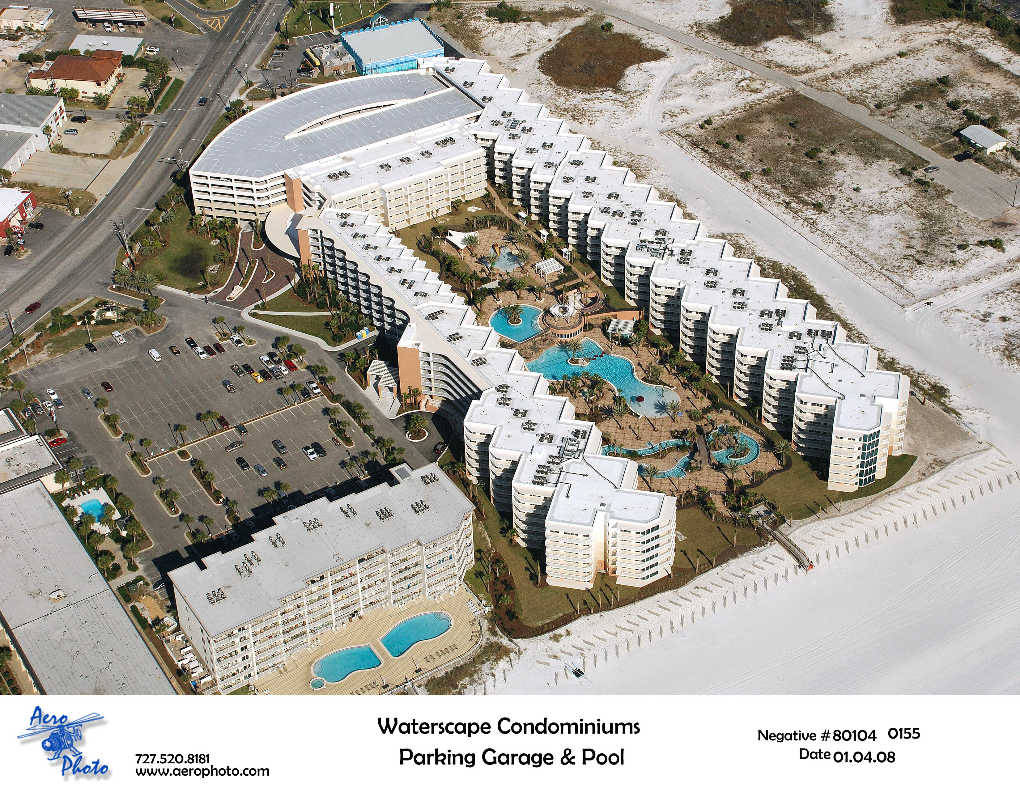



v
-00
-00
-01
-09
-15
-29
-19
-06
A
B

-01
-02
-30
-10
-07=7
-05
-03
-20
-28
-22
-04
-00
-02
-06
-01
6-story
Parking Deck
Summer Place Condo
-10
-14
-05
-07
-02
-06
-12
-03
--27
-21
-23
-25
-11
-13
-17
-05
-03
-28
Holiday Inn
Now under construction
opens
Spring 2014

County access
path
C
-35
Santa Rosa Blvd.
Alvins Island
Waffle
House
Old Bay Steamer
-33
-31
Lobby
Fitness Center
10’ Waterfall
Hot Tub 1
Kiddie Play Park
Heated Pool
Hot Tub 2
Zero Entry Pool
LazyRiver

490’ of Private Beachfront
w/Dune walkover &
shower station
wwww
DENISE STEGNER - #1 Waterscape Realtor
850-865-9301 / denise@destin.org
www.WaterscapeSales.com

